# Lesson 48 单词讲解

1. pull v. 拉，拔

pull out a tooth

push v. 推

cotton ['kɔtn] 药棉

1. collect v. 搜集，收集，取走

collect evidence collect information

collect stamps collect matches boxes collect the mail

collection n. 收集，收集品，收藏品

1. meanwhile adv. 同时

Our boss reported to the supervisor about the problem. Meanwhile, we were trying to solve it.

nod [nɔd] v.点头

# Lesson 48 课文&语法讲解

本课重点:

复习课

复习第二单元讲过的全部内容



* 1. Dentists always ask questions when it is impossible for you to answer.

时间状语从句

it 形式主语／to answer 真正的主语

* 1. My dentist had just pulled out one of my teeth and had told me to rest for a while.

并列句的省略平行结构

to rest = to have a rest

v. n.

He knew I collected match boxes and (he) asked me whether my collection was growing.

He可以省略

并列句的省略平行结构

* + 1. He knew I collected match boxes and (he) asked me whether my collection was growing.
    2. He then asked me how my brother was and whether I liked my new job in London.

并列句的省略平行结构

* + 1. In answer to these questions I either nodded or （i）made strange noises.
    2. Meanwhile, tongue was busy searching out the hole where the tooth had been.
    3. When the dentist at last removed the cotton wool from my mouth, I was able to tell him that he had pulled out the wrong tooth.

双宾语从句

# Lesson 48 知识拓展

本课重点:

复习第二单元的内容并列句／主从复合句

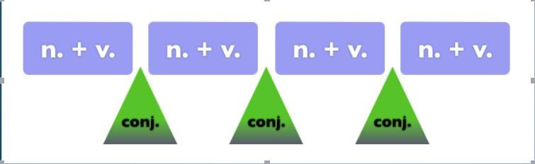并列句／主从复合句 （多件事）

并列句／主从复合句 （多件事）

The principle of British welfare is no longer that you can insure yourself against the risk of unemployment and receive unconditional payments if the disaster happens.

表语从句 看 that前面是什么词 is 系动词

并列句／主从复合句 （多件事）

The principle of British welfare is no longer that you can insure yourself against the risk of unemployment and receive unconditional payments if the disaster happens.

并列句／主从复合句 （多件事）

The principle of British welfare is no longer

that you can insure yourself against the risk of unemployment and receive unconditional payments

if the disaster happens.

并列句／主从复合句 （多件事）

